**Day 4 assignment**

**Question 1**: Find out the mail servers of the following domain :

Ibm.com 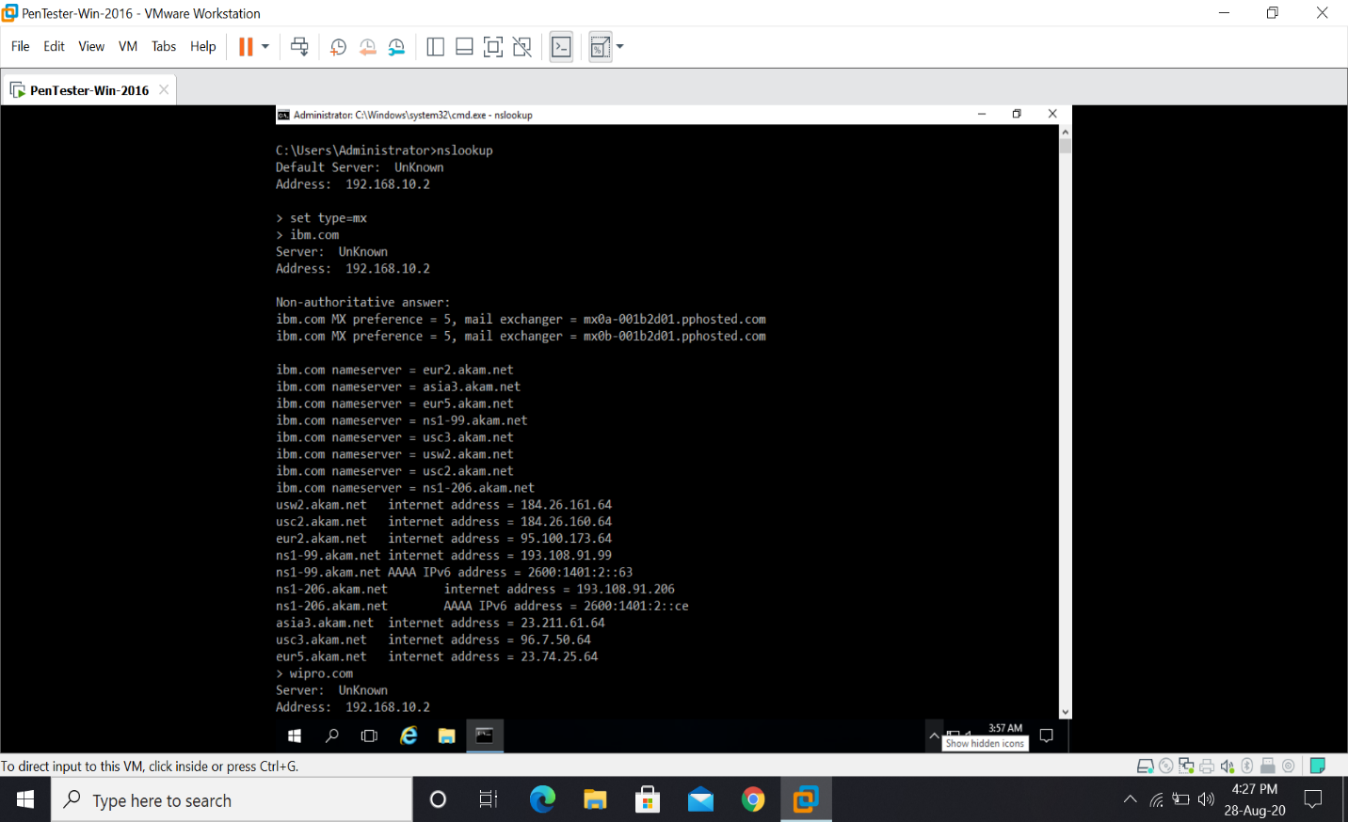

Wipro.com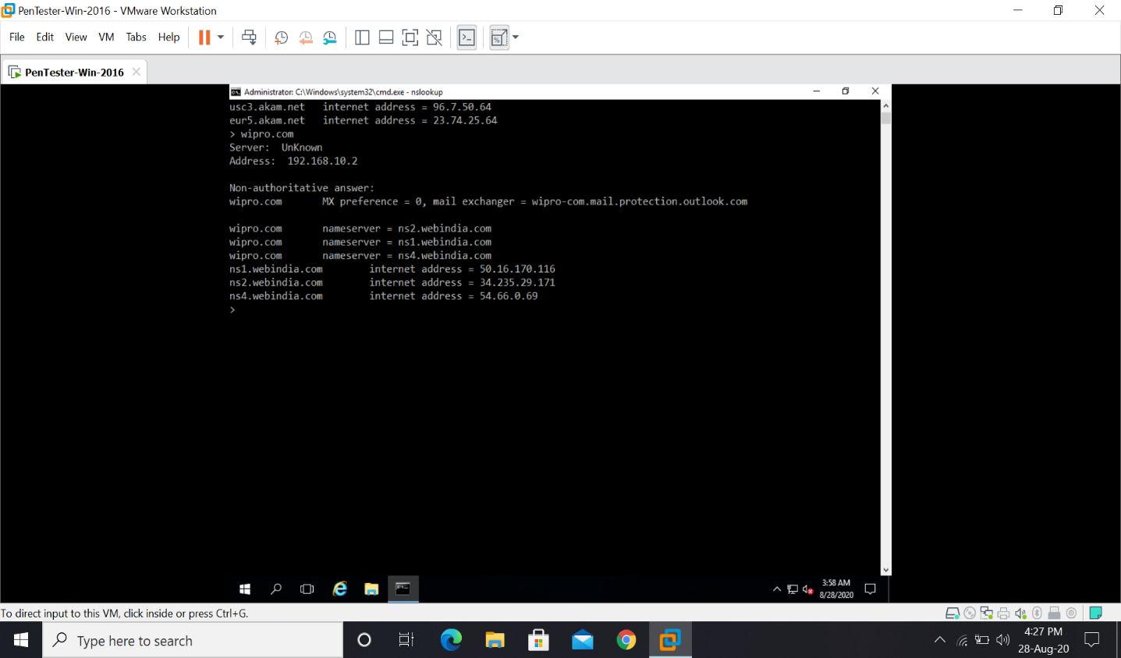

**Question 2**: Find the locations, where these email servers are hosted.

Ibm.com

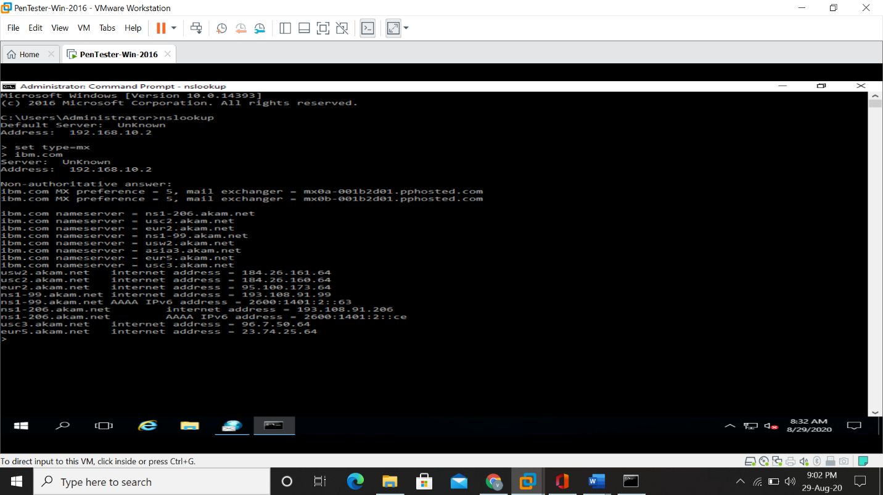

Wipro.com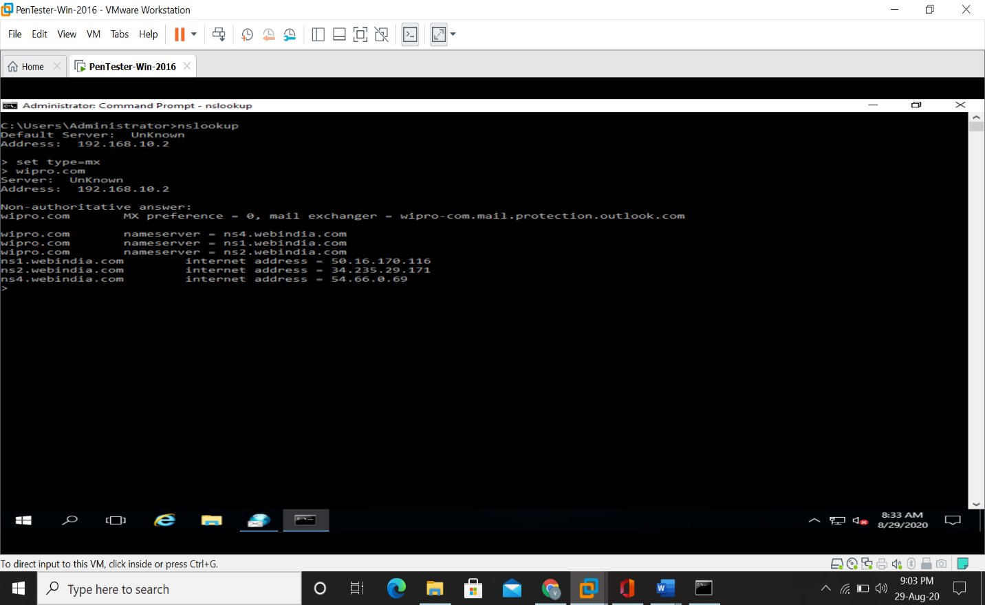

**Question 3:** Scan and find out port numbers open 203.163.246.23

Code. **nmap -Pn -sS -A -v 203.163.246.23**

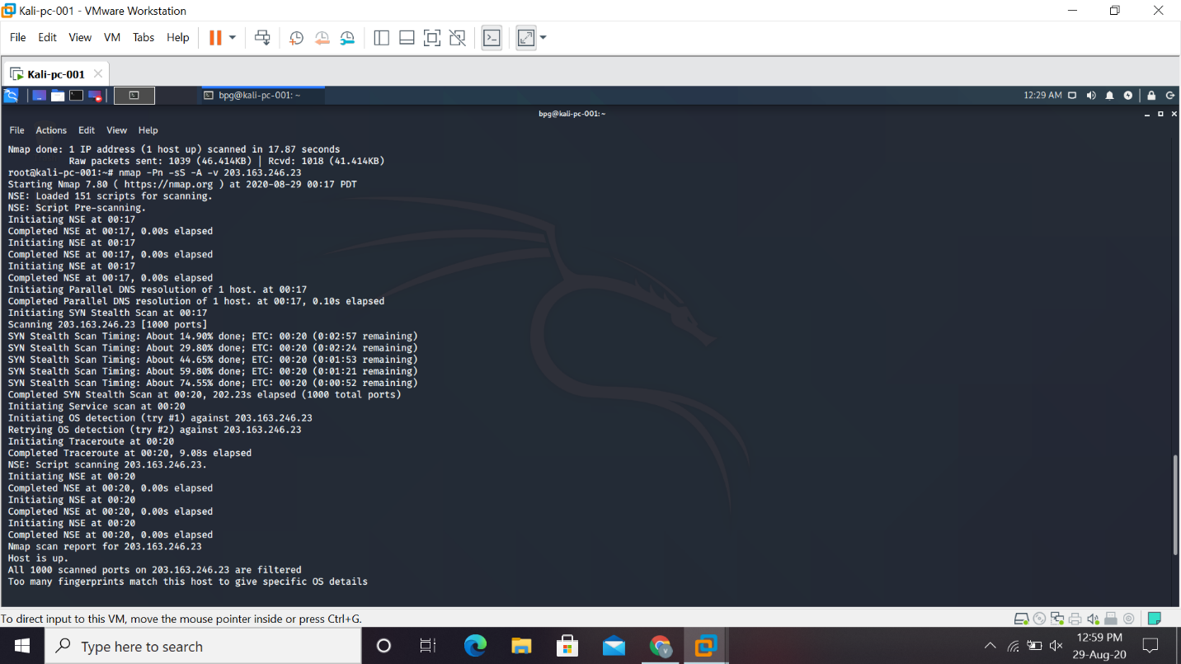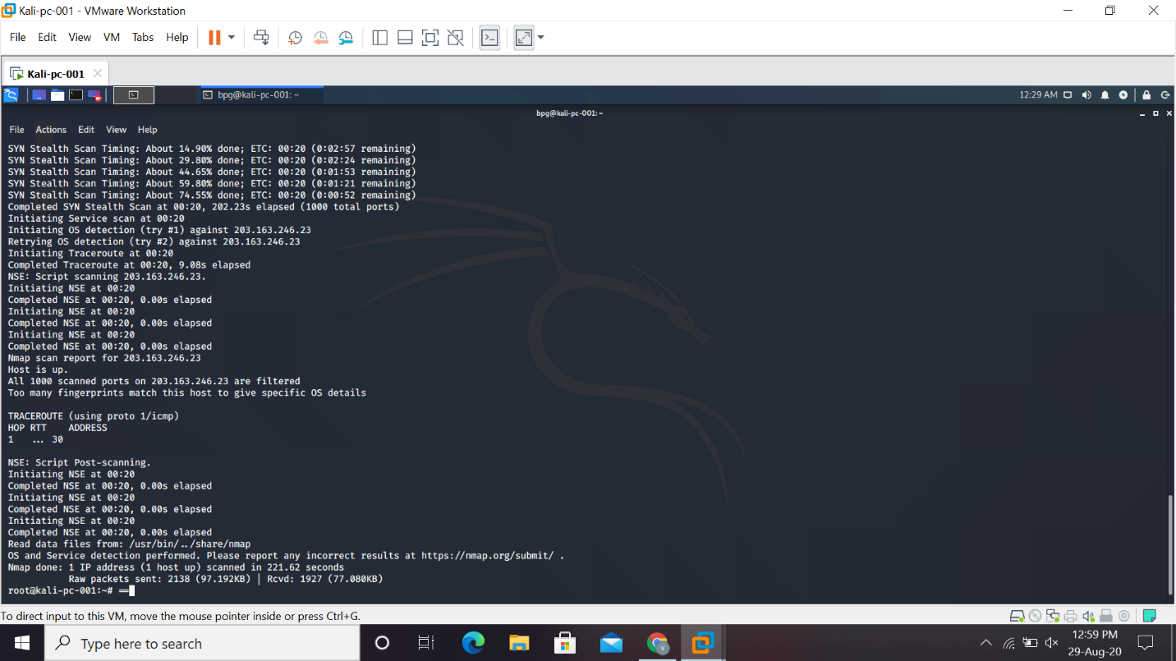

Question 4: Install nessus in a VM and scan your laptop/desktop for CVE.